PADDY POWER WORLD

DARTS
CHAMPIONSHIP
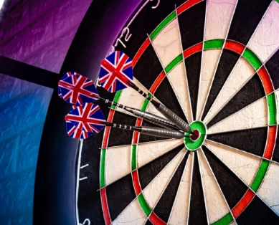
2026 - 2027

4 X TICKETS TO THE PDC FINAL
TO BE HELD AT ALEXANDER PALACE, LONDON
DECEMBER 2026 – JANUARY 2027


Contact Details : Chris Webb
Email : enquiries@chrisjwebb.com

