Remedy Oak’s
with Harry Redknapp
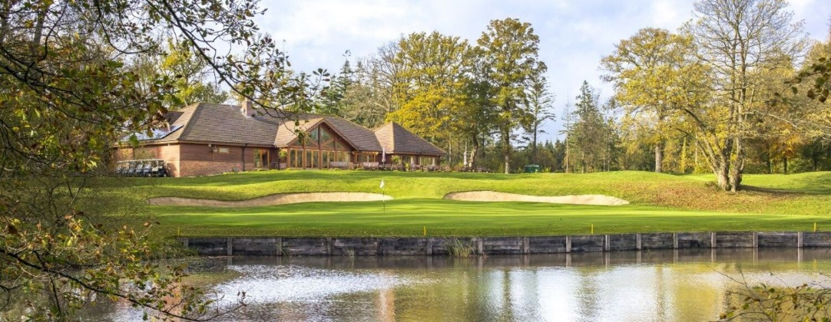

A round of golf for 3 at Remedy Oak Golf Club with Harry Redknapp
A unique opportunity to play a round of golf with the former King of The Jungle, Harry Redknapp. A football legend, as well as a winning racehorse owner, hear football anecdotes from Harry, and get the inside track on what is going on in both sports. It is also an opportunity to play Remedy Oak, a course that Peter Alliss described as one of the most superbly constructed courses he had seen. Remedy Oak is largely an exclusive club for members and their guests, with only a few tee times made available for visitors.
To be played at a time to be mutually agreed, before autumn this year, or between spring and autumn 2027.

Booking details please contact: Paul Eldridge
Email : paul@lindridge.com

