Chalet Dow
Châtel, France
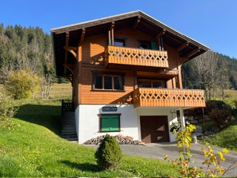
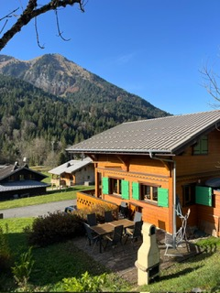

This traditional Savoyard Chalet offers self catered accommodation for up to 8 people to a high standard. There is space in the living room for lazing in front of the wood-burning stove. A large kitchen makes catering easy & the open plan layout means that the cook(s) are not excluded from the social banter. Chalet Dow makes a great summer base as well.
. 4 Bedrooms – Sleeps 8
. Geneva Airport is 1.5 hours away
. Car hire is available at a heavily discounted rate from Geneva Airport
. Ski lifts 5 mins away
. Restaurants and Bars within 5 mins away
. La Chapelle D’Abondance and Chatel are local towns 5 mins away

Golf is also available in less than a 40 minute drive at the
‘Evian Resort Golf Club’ which is a Championship Golf Course which has hosted the Women’s Aumndi Masters for the last 31 years.
Overlooking Lac Leman (Lake Geneva)
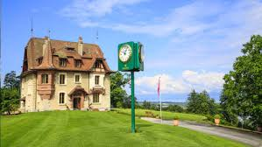


Summer activities include:
. white water rafting
. parapenting
. mountain biking
. hiking

Dates: 1 week stay anytime apart from
19th Dec 2026 – 9th Jan 2027 or 6th Feb 2027 – 27th Feb 2027
Website: vrbo.com – 10534 (is the accommodation)

For booking details please contact : Chris Webb
Email : enquiries@chrisjwebb.com

