Luxury Apartment in
Baia Da Luz - Portugal
1 x 1 WEEK STAY
Dates : September 2026 – May 2027
- 3 -bedroom, 2-bathroom recently renovated ground-floor apartment
- Spacious open-plan living and dining area
- Private west-facing terrace with outdoor dining and sun loungers
- Landscaped garden area
- Access to pools including heated pool
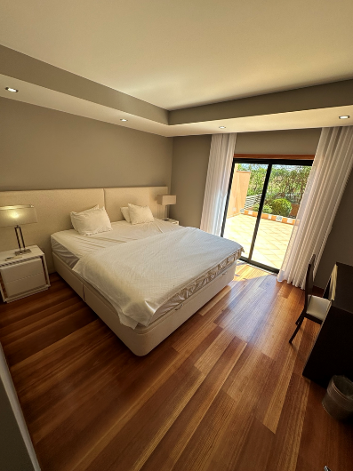
- Tennis courts and playground
- On-site restaurant and bar
- Walking distance to beach and amenities
- Close to Lagos Marina
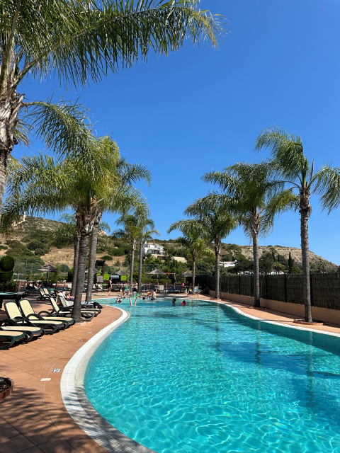
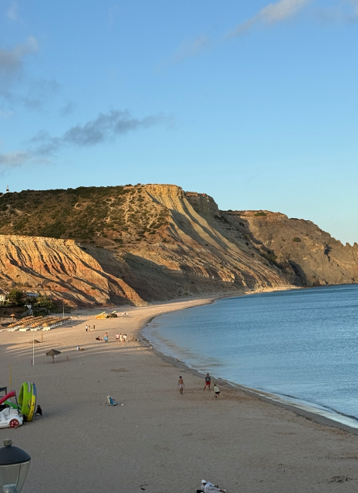
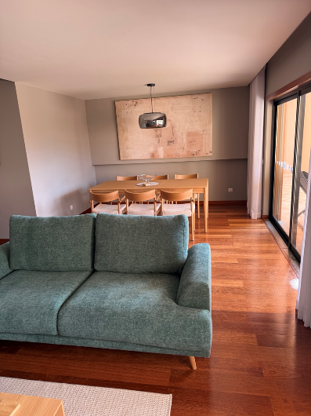
- NB. There is building works on an adjacent piece of land

